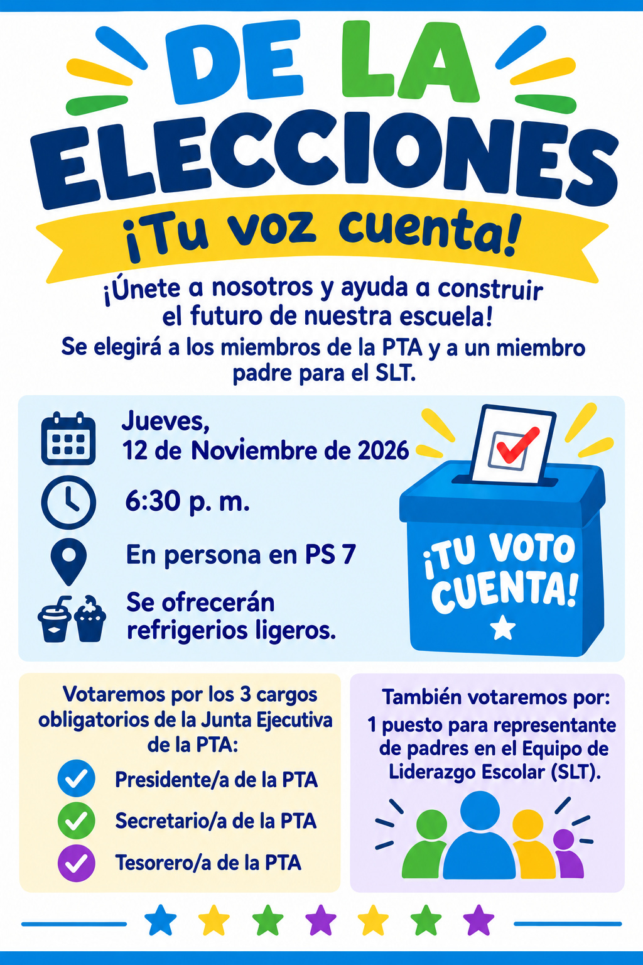
Distribution Date: October 29, 2026

